Title: Kyaw Family Memorial Album

Photo for Section:

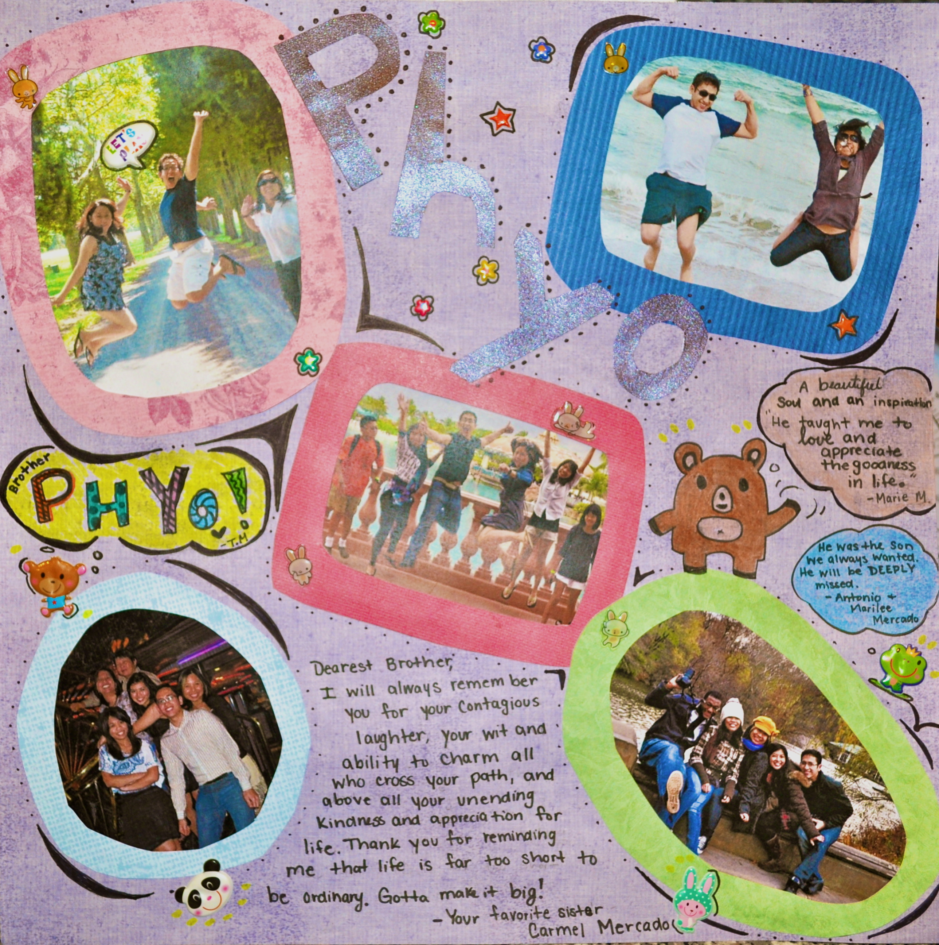

Text:

**Kyaw Family Memorial Album**

In Phyo's memory, a memorial album – containing photo collages, poems, stories, and other creative pieces by Phyo’s friends – was created and sent to the Kyaw family who lives in Burma. We thank everyone who has participated thus far for your thoughtfulness and kind efforts!

This album is an ongoing project and will continue until the album fills up. There are currently a limited number of spots left. If you want to be part of this album, please email us (link to pnnk-director@mit.edu) and we will be glad to send you further information. When you complete your album page, you will have the option to have your page displayed here on the website as well!

Comment:

** Can we add a photo gallery of some of the pages to this section?

Link to Dropbox folder “Sheet of Memories”: <https://www.dropbox.com/sh/hkh5mg5ulltbce3/Pg_1Mb2RAf>

Photos to include in gallery: everything in “Notes” (except the rtf if formatting is difficult) and “Pictures” sub-folders.